Intro & Background Checkpoint

Intro: Funnel Paragraph
- 2-3 sentences introducing your topic
- 2-3 sentences introducing each of your main arguments
- 1 sentence thesis at the end

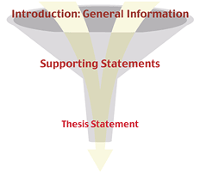

Background: Teach the reader the history they need to know to understand your argument
- 2 paragraphs in length (Honors Paper could be 3 paragraphs)
- 3-5 pieces of historical evidence for each paragraph
- Variety of sources need to be used

